Decemeber 17, 2025 – Board Meeting Minutes

Date: December 17, 2025
Time: 3:00 pm
Location: 820 Pole Line Rd, Davis, CA 95618
Board of Trustees: Chairperson Kate Bowen, Vice Chairperson Stephen Souza Board Members: Gail Jankowski (Absent), Ro Mottsmith, Alex Meyer, and Joseph Cattarin.
Staff: District Manager Jessica Smithers; Family & Business Coordinator Iris Tinsley; Groundskeeper Dylan Weiss; Groundskeeper David Crowley
Open Session
I. Call to Order 3:16pm
II. Approval of the Agenda (4-0-0)
III. Trustee Announcements
a. Conflict of interest
None.
IV. Public comment
None.
V. Approval of the Minutes (4-0-0)
VI. Informational Items
a. District Manager Report
Presented and received.
b. District Project Update – Roadway Expansion and New Service Shed
Madrone Ecological has finalized the Arboreta review and roadways have been shifted slightly to avoid tree removal. The roadways are now in final approval with BKF Engineering. The City of Davis

has taken 6 months to approve our new service shed permits. We are expected to receive permits by the end of the year.
VII. Action Items
a. Yolo County Authorization Form – Adding Iris Tinsley as an approved signer.
This form gives Iris permission to submit on behalf of the District. Yolo County Authorization Form will be submitted to Yolo County.
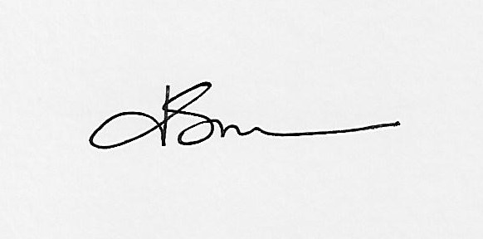
Motion to approve as presented. Stephen Souza 1st, Ro Mottsmith 2nd, (5-0-0) (Ro arrived and voted)
Adjournment
3:40pm
Next meeting date is set for Wednesday, February 18, 2026

