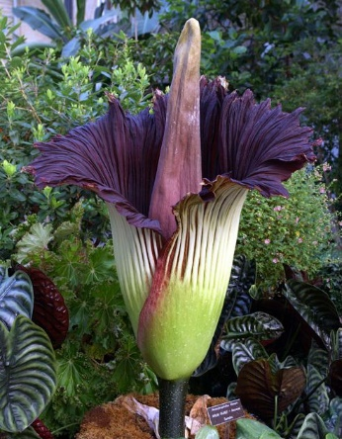

TITAN BURIAL
Burial Process:  A titan burial utilizes a fully sealed vault. The casket is lowered into the vault and once in place, the titan lid is placed and secured with silicone. | Benefits:  - Fully sealed vault provides protection from the elements.  - Reinforced construction protects the casket from heavy equipment.  - In-ground tomb interment.
Service Details:

When planning a green burial, the District will provide the following for your service.
- Up to 50 chairs
- Canopy
- Podium
- Microphone and speaker
- Table for floral / memorabilia display
- Bucket of earth with shovel
- Pallbearer service
- Floral grounds stakes
- Temporary name marker

