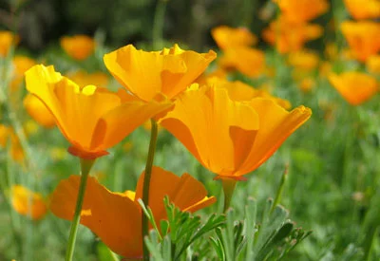

GREEN BURIAL
Burial Process:  A green burial is a way of caring for loved ones with minimal enviromental impact. Green burials emphasize simplicity and sustainability. The body is not embalmed nor is it cremated. It is simply placed in a biodegradable casket or shroud and interred without a concrete vault. | Benefits:  - Simplistic approch  - Low cost compared to a standard or titan burial  - Eco-friendly
Service Details:

When planning a green burial, the District will provide the following for your service.
- Up to 50 chairs
- Canopy
- Podium
- Microphone and speaker
- Table for floral / memorabilia display
- Bucket of earth with shovel
- Pallbearer service
- Floral grounds stakes
- Temporary name marker

