DAVIS CEMETERY
SELF-GUIDED
HISTORY TOUR

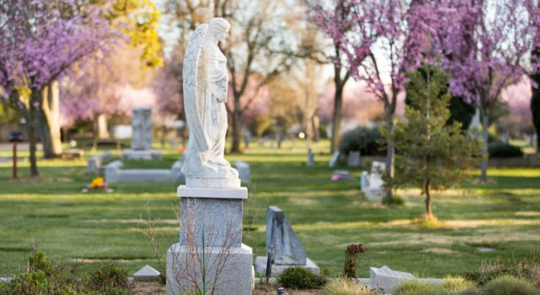

NAME | FOUND IT!
Virginia Saunders Dixon
Andrew Gordon Anderson
Betsy and Joe Truffini
Larry McFarland
Lysle D. Leach
Charles Dodge
Albert June Plant
Lois Plant Beckett
J. Price Gittinger
John B. Anderson
Mary and Sophia Stelling
H.M. Eaton
C.A. “Cal” Covell
The Sikes Family
Yuri Druzhnikov
Jack D. Forbes
George W. Pierce
Ralph Aronson
William Henry Scott
Nancy Dew
James Henry Meyer
The Chiles Family
Harriet Elisha “Hattie” Weber
Narcissa Peña
Valente Frances Dolcini & June Rose Plant
Roy Bainer
John H. Jones
