Monument Companies
Blake’s Monuments
No storefront address (will come to your home with laptop computer)
530-662-4265

Bryan-Braker Monuments
615 Merchant Street, Vacaville CA 95668
707-448-4900 or 707-425-4697

Cache Creek Monuments
339 County Rd 98 (corner of Main St. & Hwy 16)
Woodland, CA 95695
530-662-4450

Diamond Memorials
Butte House Rd, Sutter, CA 95982
530-755-4989

Pugh Memorials
231 West Main Street, Woodland CA 95695
530-662-1251

Ruhkala Monument
1001 Broadway (at 10th St, across from the old cemetery), Sacramento, CA 95818
916-441-2846

Sharer Monument
4946 Watt Avenue. #18 Sacramento, CA 95818
916-925-4194

Weber’s Personalized Memorials
340 Industrial Way, Dixon CA 95620

Davis Cemetery District and Arboretum
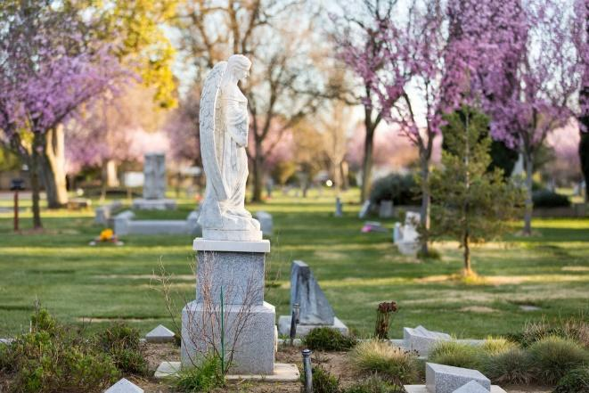

820 Pole Line Road
Davis, CA 95618

Hours: Monday-Friday, 9am-4pm

Contact information:
530-756-7807
www.daviscemetery.org

Superintendent: jess@daviscemetery.org

Assistant Superintendent: judy@daviscemetery.org

Residential Interment Right Fees
Plot Endowment*
Casket.……………...1,600.00 500.00

Infant .…………………650.00 200.00

Cremation……….……525.00 225.00

Double Cremation…...900.00 300.00

Above Ground
Plaza facing Top two rows….........2,300.00 500.00
Bottom row Niche…..1,025.00 500.00
Street facing
Niche………………...1,025.00 500.00
Scattering Garden…..575.00 125.00

Hill
Upper……….………7,200.00 500.00

Middle ………….…...5,250.00 500.00

Lower ……...….…….3,575.00 500.00

J Section Expansion
Casket.……………...2,000.00 500.00

Double Cremation…1,100.00 300.00

Burials are conducted Monday-Friday, 9am-3pm. Weekend Burials incur additional costs.

* Endowment fees are for the forever care of the plot and marker and are non-refundable.
Interment Fees
Green Burial Single….………………………...1,400.00
1st Companion……………...…..1,750.00
2nd Companion………………....1,050.00
Vault Lid (plus tax)………………………400.00

Standard Burial
Single……….……….…..……...1,500.001st Companion……….……..…..1,850.00
2nd Companion……....…………1,050.00
Vault (plus tax)……..………………950.00
Companion Vault (plus tax)….…1,300.00

Titan Burial
Single…………...…...………….1,650.00
1st Companion…………...……..2,200.00
2nd Companion……...………….1,500.00
Vault (plus tax)……..……..…..…1,700.00

Cremation
Single………………………………675.00
Two Urns(simultaneously).…..…..1,000.00
Large Urn…..…………………..1,000.00

Other
Niche………………………………650.00
Infant………………………………800.00
Infant Vault (plus tax)………………….350.00

Additional Fees & Services

Monument Moving Fee
Flat Stone…………………………150.00
Up to 6”……………………………250.00
Up to 18”…………………………..500.00
Up to 30”………………………..1,000.00
Above 30”……………………….2,000.00

Weekend Burial Fee (10 am – 2 pm)
Casket…………………………...1,000.00
Cremation………………………...750.00
Niche………....……………………675.00
Scattering…………………………675.00

Non-Resident Fee
Non-Resident Fee……………..1,200.00
Former Resident…………………400.00
Clarksburg/West Sac……………350.00

Miscellaneous (plus tax)
Cremation Vault ……………...…200.00
Urn Bag…………………………….20.00
Flower Vases………...…………….20.00

We accept Cash, Check, Money Order, Cashier’s Check, Visa/Mastercard

Updated: October 16, 2019

