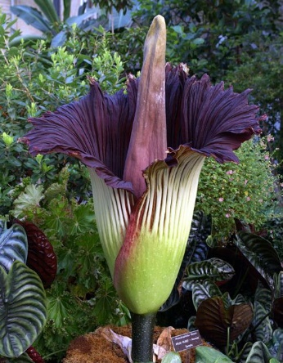

TITAN BURIAL
Burial Process:  A titan burial utilizes a fully sealed vault. The casket is lowered into the vault and once in place, the titan lid is placed and secured with silicone. | Benefits:  - Fully sealed vault provides protection from the elements.  - Reinforced construction protects the casket from heavy equipment.  - In-ground tomb interment.
Service Details:  When planning a green burial, the District will provide the following for your service.  - Up to 50 chairs  - Canopy  - Podium  - Microphone and speaker  - Table for floral / memorabilia display  - Bucket of earth with shovel  - Pallbearer service  - Floral grounds stakes  - Temporary name marker | Interment Costs*:  $3,490.25 (single) includes open and close, fully sealed vault, and tax. $5,590.25 with the purchase of a casket plot.  $4,040.25 (double 1st companion) includes open and close, fully sealed vault, and tax. $6,140.25 with the purchase of a casket plot.  $3,340.25 (double 2nd companion) includes open and close, fully sealed vault, and tax.  * pricing does not include non-resident fees, hill plots, and weekend interment fees, if applicable.

