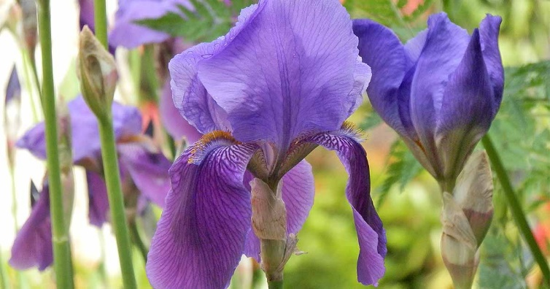

STANDARD BURIAL
Burial Process:  A standard burial is typcially chosen when the family embalms the body and seeks casket protection from the weight of the earth. A cement vault is placed in the ground and once the casket is lowered a lid is placed over the vault before earth is added. | Benefits:  - Cement vault protects the casket from the weight of the earth.  - Most commonly used interment option in the US.  - Low cost compared to a titan burial
Service Details:  When planning a green burial, the District will provide the following for your service.  - Up to 50 chairs  - Canopy  - Podium  - Microphone and speaker  - Table for floral / memorabilia display  - Bucket of earth with shovel  - Pallbearer service  - Floral grounds stakes  - Temporary name marker | Interment Costs*:  $2,528.38 (single) includes open and close, vault, and tax. $4,628.38 with the purchase of a casket plot.  $2,878.38 (double 1st companion) includes open and close, vault, and tax. $5,357.25 with the purchase of a casket plot.  $1,050.00 (double 2nd companion) includes open and close  *pricing does not include non-resident fees, hill plots.

