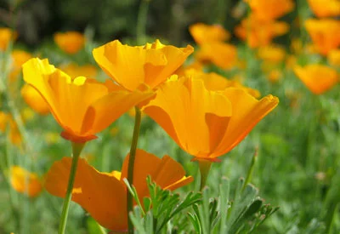

GREEN BURIAL
Burial Process:  A green burial is a way of caring for loved ones with minimal enviromental impact. Green burials emphasize simplicity and sustainability. The body is not embalmed nor is it cremated. It is simply placed in a biodegradable casket or shroud and interred without a concrete vault. | Benefits:  - Simplistic approch  - Low cost compared to a standard or titan burial  - Eco-friendly
Service Details:  When planning a green burial, the District will provide the following for your service.  - Up to 50 chairs  - Canopy  - Podium  - Microphone and speaker  - Table for floral / memorabilia display  - Bucket of earth with shovel  - Pallbearer service  - Floral grounds stakes  - Temporary name marker | Interment Costs*:  $1,883 (single) includes open and close, vault lid for stabilization, and tax. $3,933 with the purchase of a casket plot.  $2,183 (double 1st companion) includes open and close, vault lid for stabilization, and tax. $4,283 with the purchase of a casket plot.  $1,483 (double 2nd companion) includes open and close, vault lid for stabilization, and tax.  *pricing does not include non-resident fees or hill plots, if applicable.

