Monument Companies

Blake’s Monuments
No storefront address (will come to your home with laptop computer)
530-662-4265

Bryan-Braker Silveyville Monuments
615 Merchant Street, Vacaville CA 95668
707-693-0292 or 707-448-4900

Cache Creek Monuments
339 County Rd 98 (corner of Main St. & Hwy 16)
Woodland, CA 95695
530-662-4450
www.cachecreekmonuments.com

Diamond Memorials
Butte House Rd, Sutter, CA 95982
530-755-4989

Pugh Memorials
231 West Main Street, Woodland CA 95695
530-662-1251
www.pughmemorials.com

Ruhkala Monument
1001 Broadway (at 10th St, across from the old cemetery), Sacramento, CA 95818
916-441-2846
www.ruhkalamonument.com

Sharer Monument
4946 Watt Avenue. #18 Sacramento, CA 95818
916-925-4194

Weber’s Personalized Memorials
340 Industrial Way, Dixon CA 95620
707-693-0660

Davis Cemetery District and Arboretum
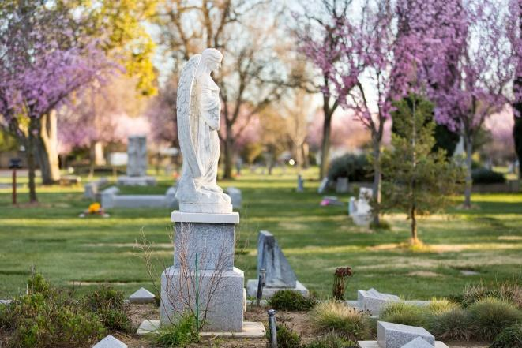

820 Pole Line Road
Davis, CA 95618

Hours: Monday-Friday, 9am-4pm

Contact information:
530-756-7807
www.daviscemetery.org

Superintendent: jess@daviscemetery.org

Assistant Superintendent: judy@daviscemetery.org

Outreach Director: embingham19@gmail.com

Residential Interment Right Fees
Plot Endowment*
Casket……………...1,600.00 400.00
Infant …………………650.00 200.00
Cremation……………475.00 125.00
Lg. Cremation……….850.00 200.00
Niche………………..2,300.00 500.00
Bottom row Niche...1,025.00 500.00
Scattering Garden….475.00 125.00
Upper Hill…………7,200.00 400.00
Middle Hill………...5,250.00 400.00
Lower Hill………….3,575.00 400.00

Burials are conducted Monday-Friday, 9am-4pm. Weekend Burials incur additional costs.

Non-Resident Fee 1,200.00
Former Resident 400.00
Clarksburg/West Sac 350.00

* Endowment fees are for the forever care of the plot and marker and are non-refundable.
Interment Fees

Green Burial Single….………………………...1,850.00
1st Companion……………...…..1,950.00
2nd Companion………………....1,050.00
Vault Lid (plus tax)………………………400.00

Standard Burial
Single……….……….…..……...1,500.001st Companion……….……..…..1,850.00
2nd Companion……....…………1,050.00
Vault (plus tax)……..………………950.00
Companion Vault (plus tax)….…1,300.00

Titan Burial
Single…………...…...………….1,500.00
1st Companion…………...……..2,200.00
2nd Companion……...………….1,500.00
Vault (plus tax)……..……..…..…1,700.00

Cremation
Single………………………………675.00
Two Urns(simultaneously).………..1000.00
Lg. Urn…………………………..1000.00

Other
Niche………………………………650.00
Infant………………………………800.00
Infant Vault (plus tax)………………….350.00
Additional Fees & Services

Marker Fee
Endowment*
Flush Marker.....….125.00 100.00
Per 6” of Height…..150.00 125.00

Monument Moving Fee
Flat Stone…………………………150.00
Up to 6”……………………………250.00
Up to 18”…………………………..500.00
Up to 30”………………………..1,000.00
Above 30”……………………….2,000.00

Weekend Burial Fee (10 am – 2 pm)
Casket…………………………...1,000.00
Cremation………………………...750.00
Niche………....……………………675.00
Scattering…………………………675.00

Miscellaneous (plus tax)
Cremation Vault (12” round)….150.00
Lg. Cremation Vault (9x15)……200.00
Urn Bag…………………………….20.00
Flower Vases………...…………….20.00

We accept Check, Money Order, Cashier’s Check, Visa/Mastercard

Updated: January 14, 2019

